Name: | ___________________________________________________ |  |  |  |  | Date: ___________
 | Subject - Year 9 Mathematics  Investigation 2, 2013  Topic – Perimeter & Area  In class component |  |  |  |  | 47  = %
Total Time: | 60 minutes
Reading Time: | 5 minutes
Working Time: | 55 minutes
Weighting: | 6% of the year.
Equipment: | Scientific Calculator
Date out: |  | Week ____ Date _____________ |  | Date Due: | Week ____ Date _____________
Assignment weighting: |  | 6% of the year
AIM: In this assessment, you will be investigating area and perimeter for simple and compound shapes.
There are two parts to this assessment:
Item | Purpose | Marks available
Take-Home | To expand your knowledge and skill with Perimeter and Area. | 5
In-Class | To test your knowledge and skill with Perimeter and Area. | 42

This In-Class part is to be completed at in class and you have one session to complete it. It will be run under exam conditions, in the same manner as exams and assessments in future years, in order that you become accustomed to them.

You are permitted the following:
- Take Home Component
- A scientific calculator
- Normal writing instruments
You will not be permitted to borrow equipment from others during the assessment.

Please make sure you are using the appropriate units and show your working. In order to get maximum marks on this assignment you must show working and use the correct units.

Mark collection
Question | Marks available | Marks achieved
1 | 1
2 | 3
3 | 3
4 | 6
5 | 1
6 | 4
7 | 2
8 | 3
9 | 3
10 | 5
11 | 5
12 | 6
Take home | 5
Total | 47

SECTION A: PERIMETER
1 | Perimeter of a circle [1 mark]
 | Calculate the length of the perimeter of a circle of diameter 30cm
2 | Perimeter of a semi-circle [3 marks]  Calculate the size of the perimeter of a semi-circle having a radius of 7cm
3 | Perimeter of a quarter circle [3 marks]  Calculate the perimeter of a quarter circle with a diameter of 16 cm
4 | Perimeter of a part circle [6 marks 3, 3]  - Describe how you would calculate the perimeter of a 45 degree section out of a circle of radius 5m.  - Now do the calculation
5 | Perimeter of a scalene triangle [1 mark]  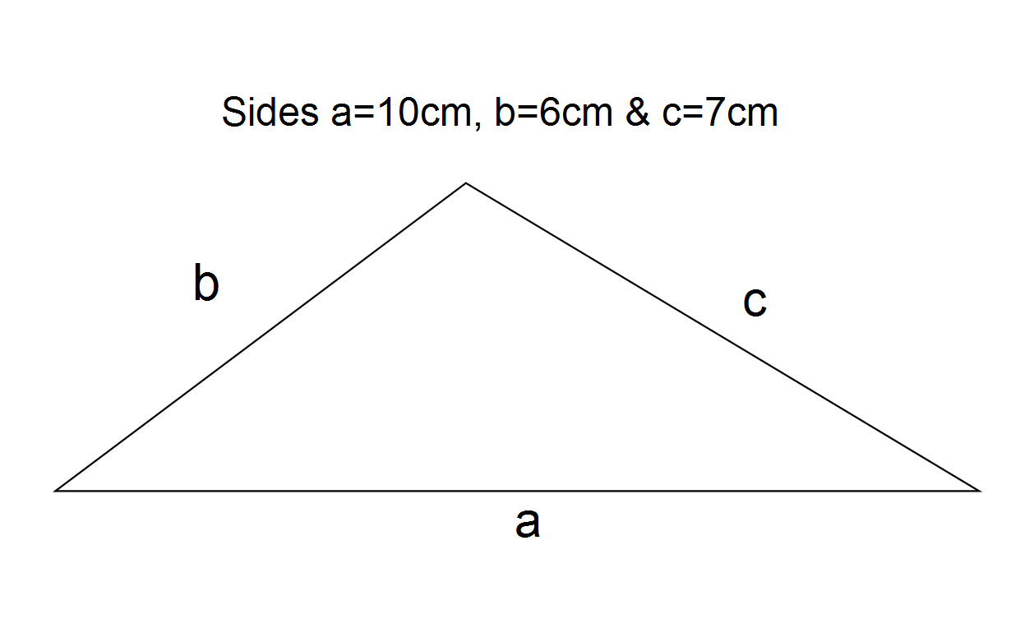  Calculate the size of the perimeter
6. | A non-scalene triangle [4 marks: 2, 2]  - Describe how would you calculate the perimeter of a triangle with all 3 sides 8 m?  - Now perform the calculation

SECTION B: AREA
7. | Area of a circle [2 marks]
 | Calculate the area of a circle 20km wide
8. | Area of a semi-circle [3 marks]
 | Calculate the area of a semi-circle having a radius of 70mm
9. | Area of a quarter circle [3 marks]
 | Calculate the area of a circle of diameter 50cm with a quarter removed.
10. | Area of part of a circle [5 marks: 2, 3]
- Describe how would you calculate the area of a 45 degree piece of a pie of diameter 30cm?

- Now do the calculation:

11. | Area of a triangle [ 5 Marks: 2, 3]
 | Calculate the area of the following:
 | a) Non-right angled triangle  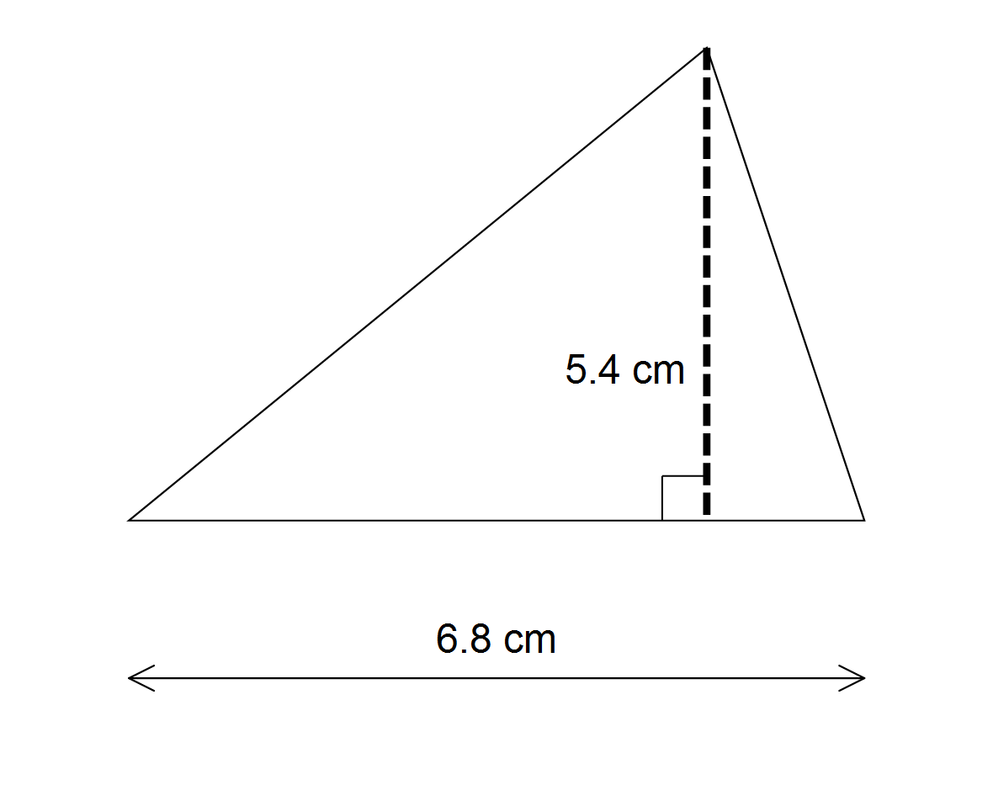 | b)Right angled triangle  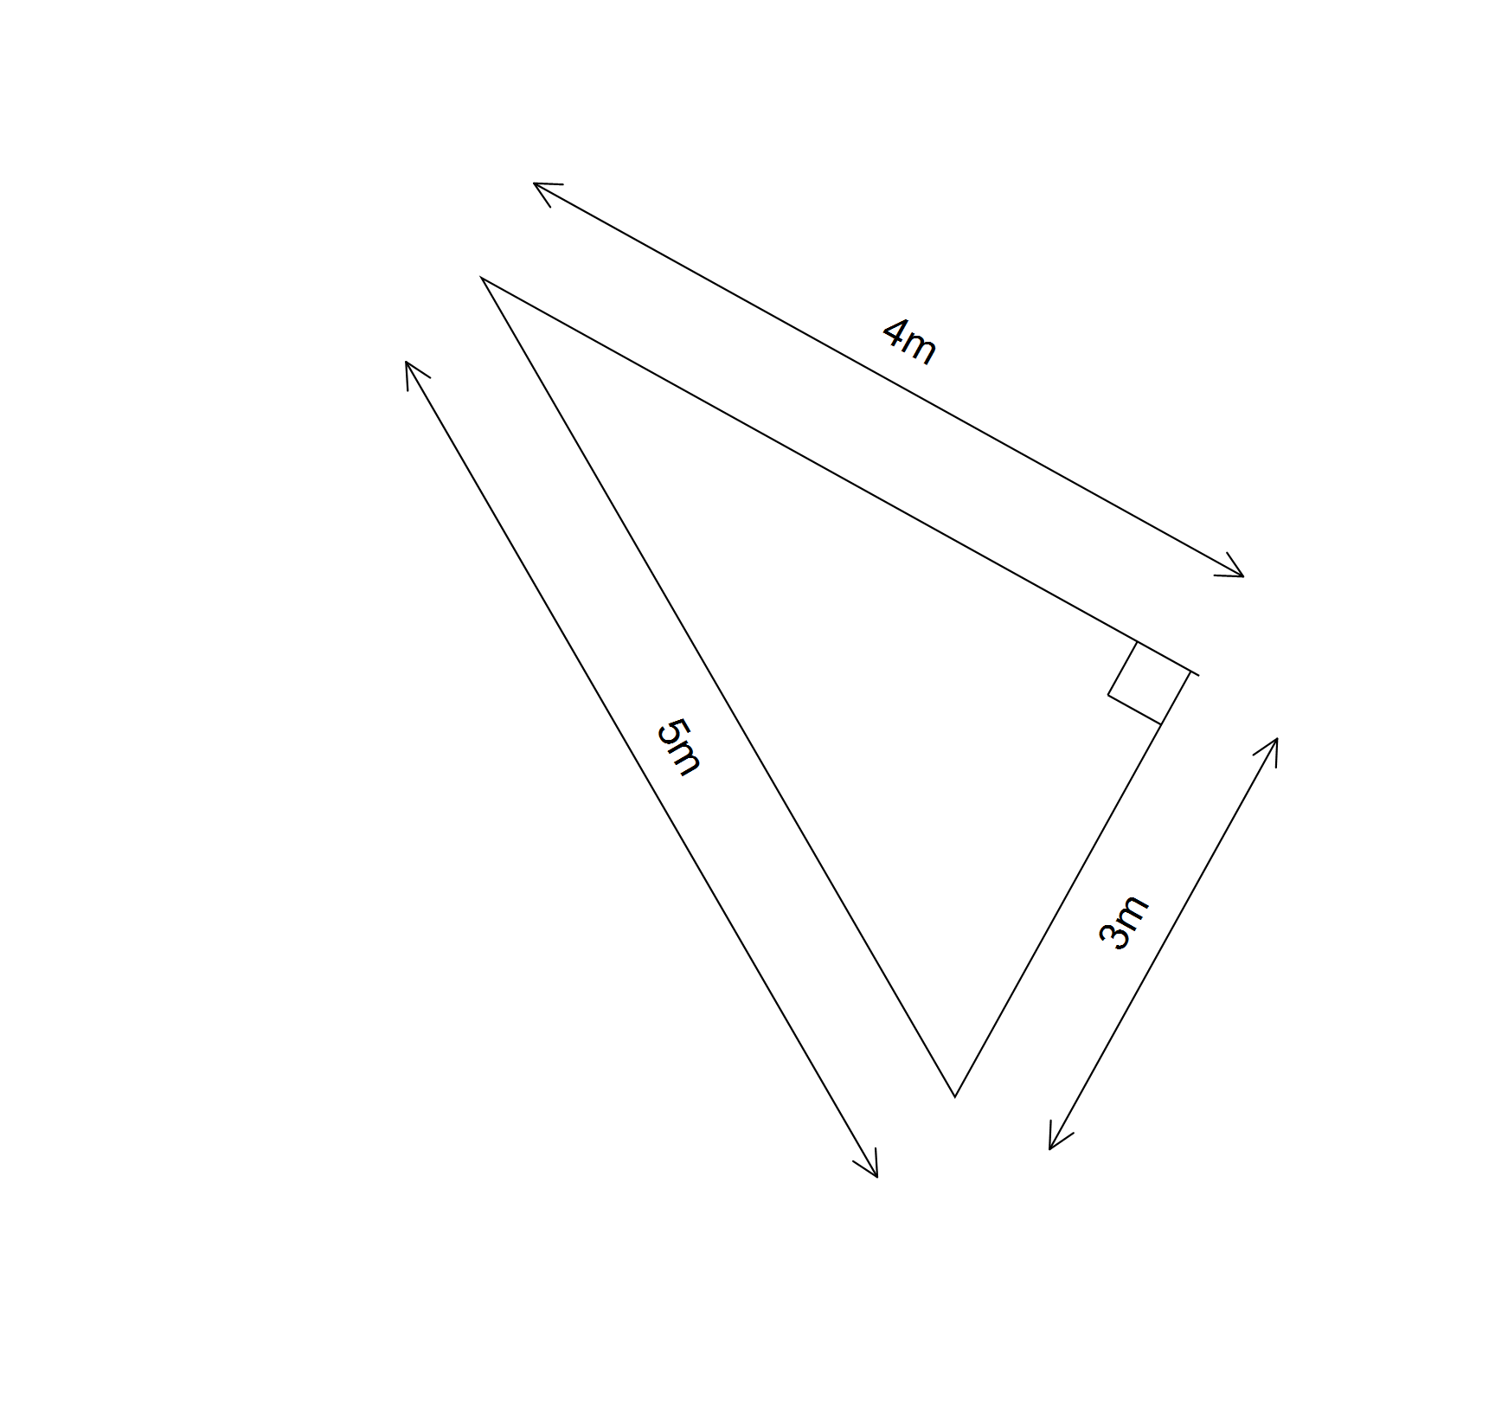

12. | Area of a triangle using Herons Formula [6 marks: 5, 1]
 | Use Heron's formula to calculate the area of a triangle with sides 3m, 5m & 4m
 | Compare your answer to that in question 11 b). What do you notice?

